Tab 1

**Class 9 Physics Free Material**

**(Lectures, Notes, Guess Paper, Most Important Questions)**

**All Lectures Uploaded on YouTube. Click link below:**

[**https://tinyurl.com/fkm9-physics**](https://tinyurl.com/fkm9-physics)

**All Free Notes Uploaded. Click the link below:**

[**https://tinyurl.com/fkm9-notes**](https://tinyurl.com/fkm9-notes)



Most Important Questions. Click the link below:

[**https://tinyurl.com/fkm-grandtests**](https://tinyurl.com/fkm-grandtests)

**Chapter 1: Physical Quantities and Measurement**

**Physics:** It is the study of matter, energy and their interaction which defines the laws of nature and surroundings.

**Branches of Physics**

**1. Atomic and Nuclear Physics -** This is a branch of physics that deals with the study of Radioactivity and Nuclear Weapons

**2. Electromagnetism -** Electricity and Magnets

**3. Mechanics -** Laws of Nature

**4. Optics -** Glass

**5. Oscillations and Waves -** Travel of Light, Sound and Energy

**6. Quantum Physics -** Study of Energy and Matter at most Fundamental Levels

**7. Relativity -** Time and Space

**8. Thermodynamics -** Heat Energy and Temperature

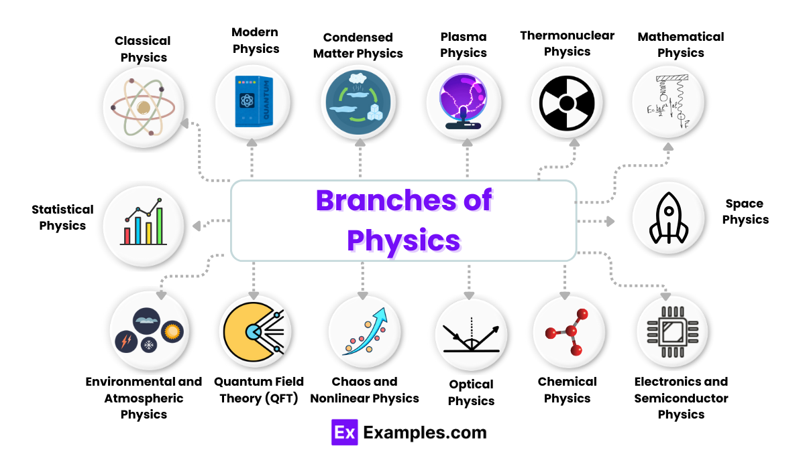

**Physical Quantities:** Quantities that can be measured. It is expressed as a magnitude

(number) and a unit. (E.g. 10 kg, 30 second).

There are two types:

**1. Base -** Time, Mass, Length.

**2. Derived -** Weight, Force, Speed

**Non-Physical Quantities:** Quantities that can’t be measured. *Example:* Color.

***SI Units (System International):* French System for Measuring Units.**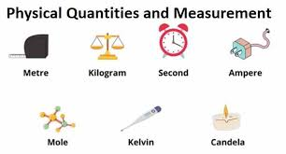

**SI Base Units:**

**1. Amount of substance (n) -** mole (mol),

*e.g. 6 mol - 6 moles*

**2. Electric Current (I) -** Ampere (A).

*e.g. 4 A - 4 Ampere*

**3. Length (l) -** Meter (m).

*e.g. 2 m - 2 meter*

**4. Light Intensity (Iv) -** Candela (cd)

*e.g. 15 cd - 15 Candela*

**5. Mass (m) -** Kilogram (kg),

*e.g. 70 kg - 70 Kilogram*

**6. Temperature (T) -** Kelvin (K),

*e.g. 50 K - 50 Kelvin*

**7. Time (t) -** Seconds (s),

*e.g. 30s - 30 seconds*

**SI Derived Units:**

**1. Acceleration (a) -** meter per second squared (m/s2)

**2. Area (A) -** square meter (m2)

**3. Density (p) -** kilogram per cubic meter (kg/m3)

**4. Energy (E or U) -** Joule (J = kgm2/s2)

**5. Force (F) -** Newton (N = kgm/s2)

**6. Pressure (P) -** Pascal (Pa = kg/ms2)

**7. Speed / Velocity (v) -** meter per second (m/s)

**8. Volume (V) -** cubic meter (m3)

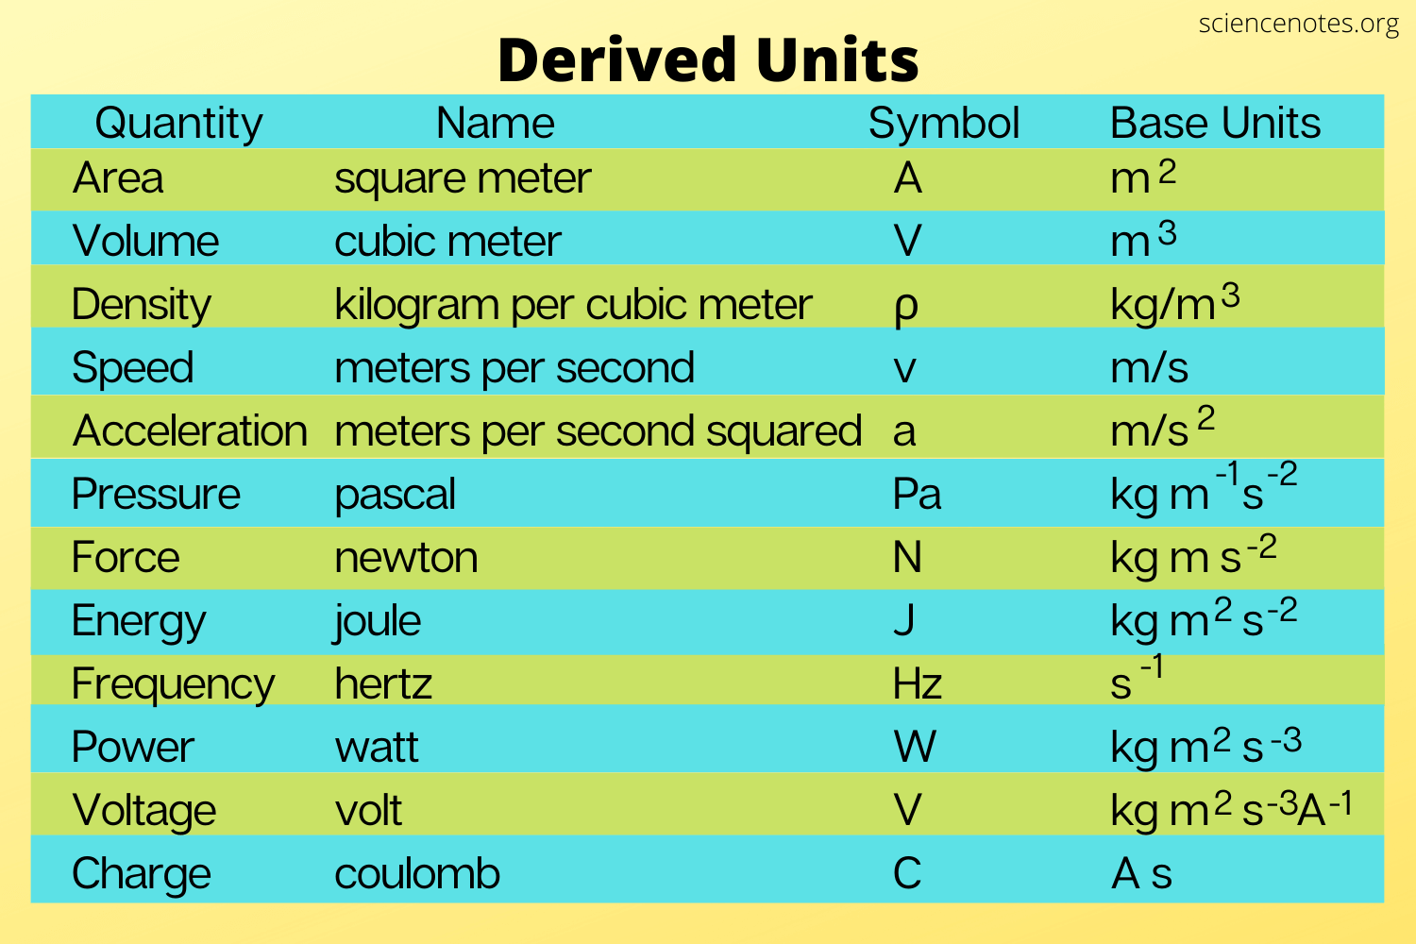

**Scientific Notation** is an easy way of expressing very large or small numbers in the power of 10.

*Example:* 74,000 , 0.00003

**Scientific Notation/Standard Form:** 7.4 x 104 , 3.0 x 10−5

**Prefixes** are used to express numbers in the power of ten which are then given a proper name.

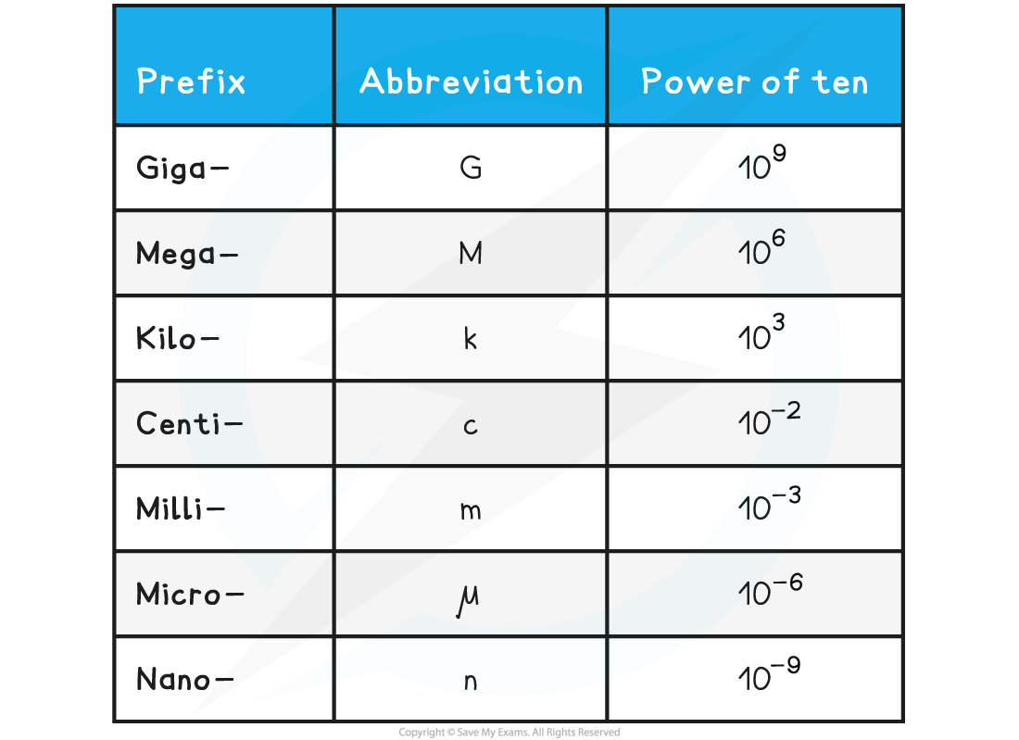

***Extra Reading Material Guide to practice SI Units, Conversions and Prefixes:*** <https://www.albert.io/blog/ultimate-guide-to-si-units-and-unit-conversions/>

**There are 2 types of Physical Quantities:**

**1. Scalar Quantities (Magnitude):** They have only magnitude and unit.

*E.g. 5m*

**2. Vector Quantities (Magnitude + Unit):** They have magnitude, unit and direction.

*E.g. 5m to your left.*



**Resultant Vector:** Final vector that you get after addition / subtraction.

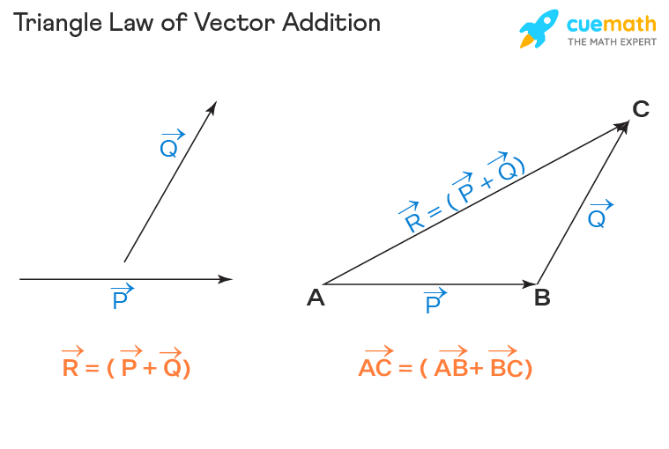

**Measuring Instruments:** *Devices/Instruments to measure quantities.*

***Types of Measuring Instruments***

**1. Meter Rule:** To measure distance (0.1cm - 1m)

(Measurement up to 1 decimal)

**2. Measuring Tape:** To measure distance (0.1cm - 25m)

(Measurement up to 1 decimal)

**3. Vernier Caliper:** To measure distance (0.1mm - 1m)

(Measurement up to 2 decimals)

**4. Micrometer:** To measure distance (0.01mm - 20cm)

(Measurement up to 3 decimals)

**5. Physical Balance:** To measure weight

(Not very accurate. Depends on the rocks)

**6. Digital Balance:** To measure weight (Very accurate. 0.0001g)

**7. Measuring Cylinder:** To measure volume (1 ml - 1 liter)

**8. Analogue Stopwatch:** To measure time (0.5s / 1s)

(Measurement up to 0 / 1 decimal)

**9. Digital Stopwatch:** To measure time (0.0001s)

(Measurement up to 3 decimals)

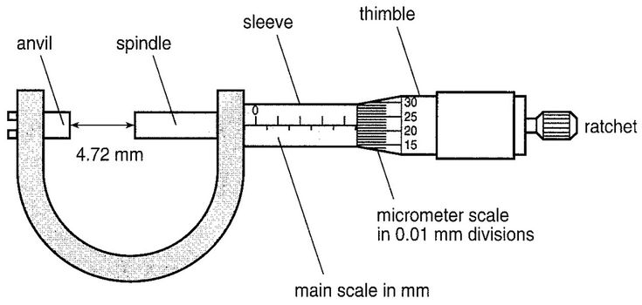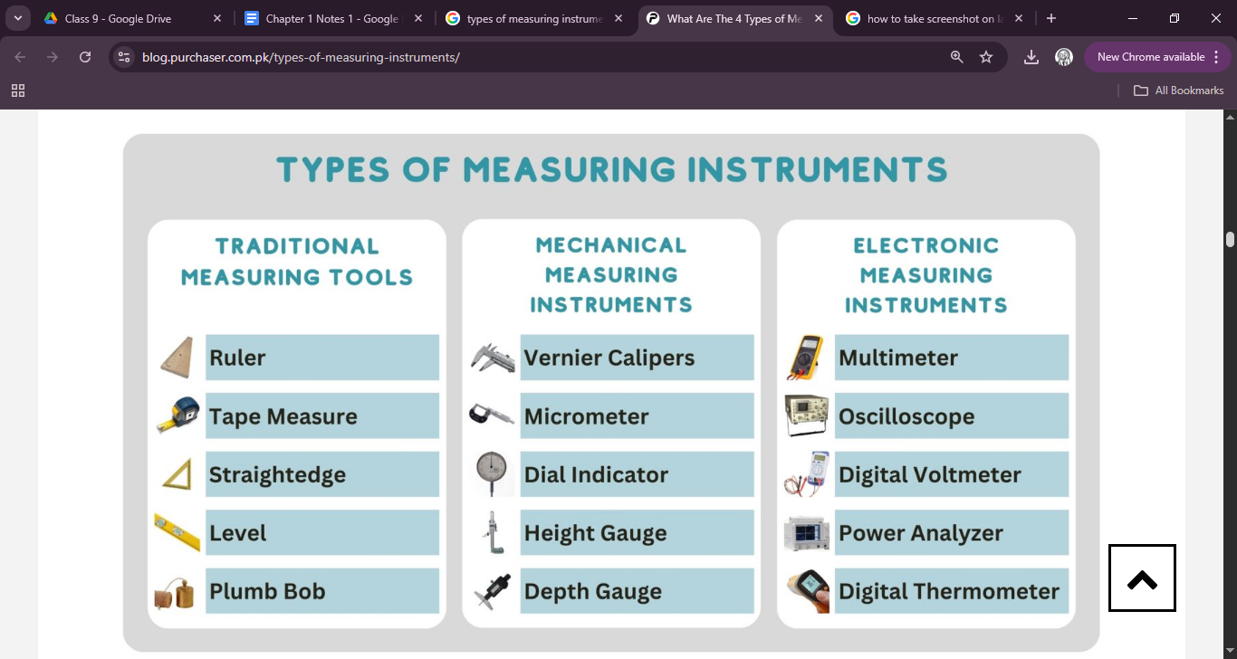

**MIcrometer Screw Gauge**

**Working Explanation:**

**English -** [**https://tinyurl.com/mnjs3dw9**](https://tinyurl.com/mnjs3dw9)

**Urdu -** [**https://tinyurl.com/4e84cdzb**](https://tinyurl.com/4e84cdzb)

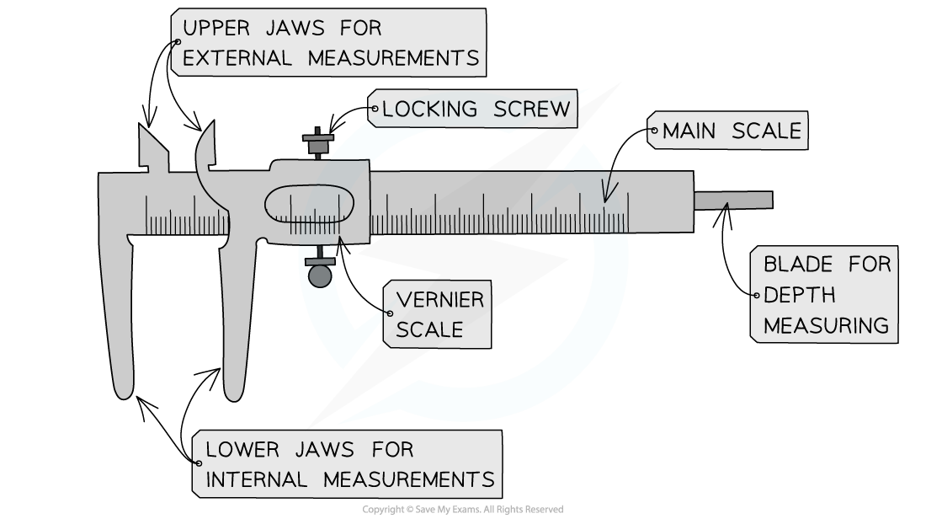

**Vernier Calipers**

**Working Explanation:**

**English:** [**https://tinyurl.com/ycyr7d4k**](https://tinyurl.com/ycyr7d4k)

**Urdu:** [**https://tinyurl.com/mr3v4w3y**](https://tinyurl.com/mr3v4w3y)

**Errors:** Difference in the actual value and the measured value of the physical quantity. *e.g. 50kg, 51kg*. There are 2 types of errors:

**1. Systematic Errors:** Mistakes made by you or because of you. They can be improved.

**a. Instrumental Errors -** Mistakes in the measuring instrument (E.g. Zero Error)

**b. Imperfections in Setup/Experiment**

**c. Personal Errors -** (E.g. Bias)

**2. Random Error:** Mistakes made naturally that aren't in your control. To improve them, take the average of values: Repeat the experiment 10 (n) times. Add all values and divide by 10 (n).

*Example:* You measure your weight 10 times and get the following values:

70, 70.1, 70.2, 70, 70.3, 70.1, 70.2, 70, 69, 69.5 (Experiment values)

Sum = 700.4

700.4 / 10 = 70.4

**Accuracy:** How close you are to the actual value. (How much error in the value)

High Accuracy means Low Error. Low Precision means High Error

**Precision:** How consistent are your measured values?

*Example:*

**Experiment 1 -** 70, 70.1, 70.2, 70, 70.3, 70.1, 70.2, 70, 69, 69.5

(High Precision)

**Experiment 2 -** 68, 65, 76, 64, 70, 61, 73, 73.4, 70, 69

(Low Precision)

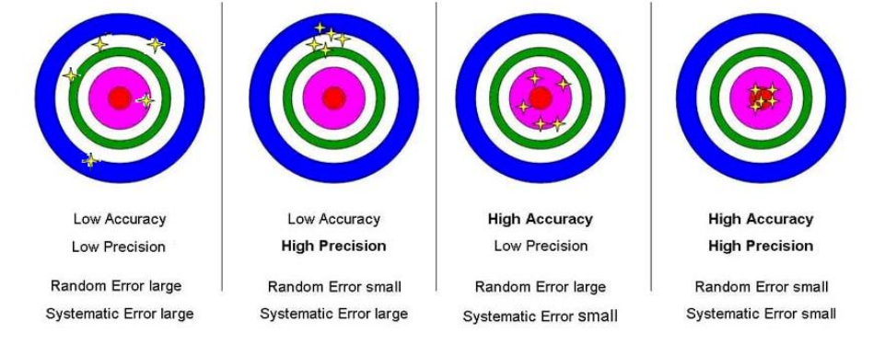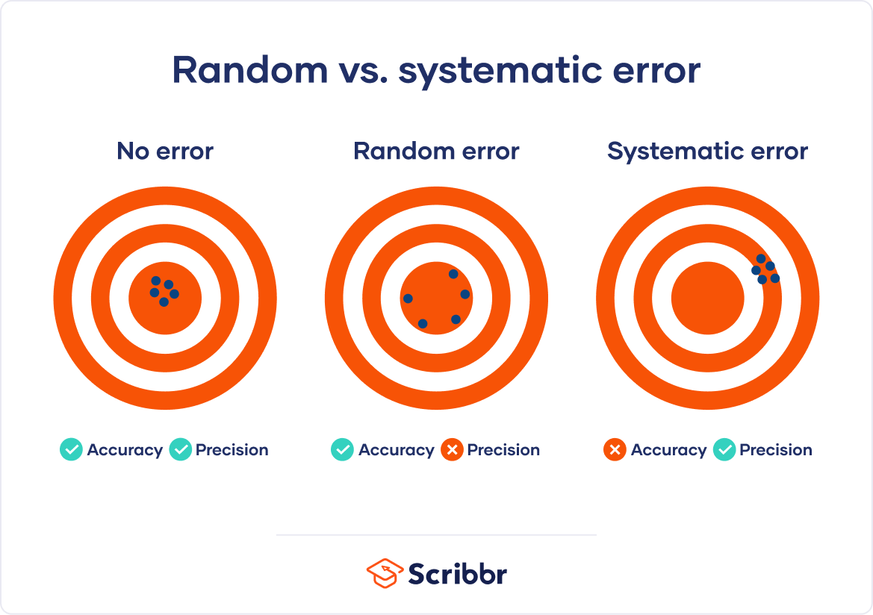

**Significant Figures**

The number of significant digits of a number

2.2365 - 5 significant figure

2.237 - 4 significant figures

2.2365 - 5 significant figure

2.24 - 3 significant figure

2.2365 - 5 significant figure

2.2 - 2 significant figure

2 - 1 significant figure

(Estimation means rounding up / down to reduce significant figures)

You will round up when the next digit is between 5 and 9.

You will round down when the next digit is between 0 and 4.

**Rules for Counting Significant Figures:**

**1. If all digits are non-zero (1-9), they all are significant.**

e.g. 1,578 - 4 significant

**2. If a zero is present between non-zero numbers, it is significant.**

e.g. 102 - 3 significant

**3. If a zero is present at the start of a number (not between non-zero digits), it is non-significant.**

e.g. 00172 - 3 significant figures

**4. If a zero is present at the end of a number, it can be significant or non-significant.**

a. 23,000 - 2 significant figures

b. 23,000. - 5 significant figures

c. 2.3 x 105 - 2 significant figures

d. 2.300 x 105 - 4 significant figures

e. 23,000.000 - 8 significant figures

**5. In decimal values, if zeroes are in the starting, they are non-significant.**

e.g. 0.00034 - 2 significant figures



